Sacred Sound as Medicine/ Queen's House

Experience the Healing and Restorative Vibrations of a
GONG Bath Immersion Meditation
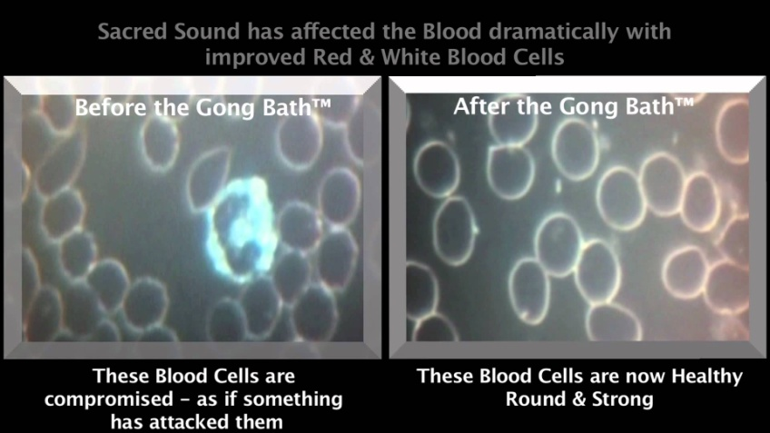
Gong Bath Immersion Meditations are considered one of the most deeply healing and restorative meditations possible, because of the deep state of relaxation attained in response to the sound vibration. Immersion in a gong bath leads to the release of stress hormones, lowers blood pressure and heals on a deep molecular level within the body. The gong also has a profound impact on the mind/spirit, as the physical sound vibrations entrain the brain to move from a beta to alpha-theta deep meditative state. A gong bath immersion meditation doesn’t involve water. Instead, you are bathed in delicious sound waves from the gong, bringing you to a deeply healing, meditative and blissful state.
2016: Resuming Thursday evenings on January 7 weekly for eight sessions until and including Feb.25. 7:00-8:30pm,
Queens House 601 Taylor Street W., Saskatoon
Drop in as it works for you ∼ $10 per session. Participation is effortless. The vibrational frequency of the gong does all the work. Please bring whatever you need to lie or sit comfortably for an hour (yoga mat or zero gravity chair, blankets, pillow, eye mask). Please refrain from wearing any scented products when you attend the gongbath meditation. Thanks in advance.
For more info: Visit: www.cognitivefmc.com or www.queenshouse.org or Call: Lynne at 306-270-3800

